 The perfect age is somewhere between old enough to know better and too young to care. How many of these do you remember?

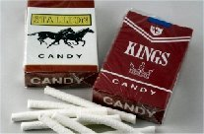                       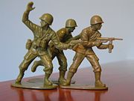                   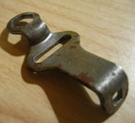

**Candy cigarettes              Plastic Army Men       Roller-skate keys   
  
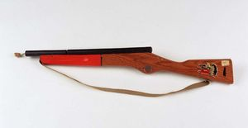    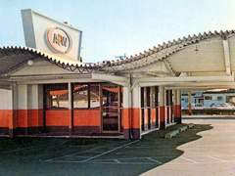     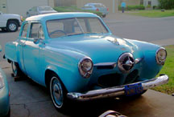  
         Cork pop guns              Drive in restaurants           Studebakers  
  
      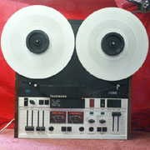                        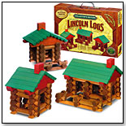**

**Reel-To-Reel Tape Decks**                 **Tinkertoys             Lincoln Logs**

**          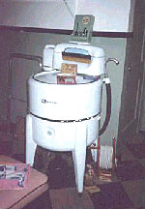            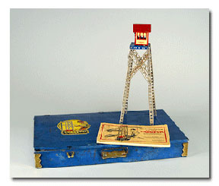  
    Topo Gigio            Washtub wringers                   Erector Sets**

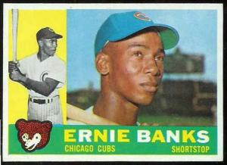                         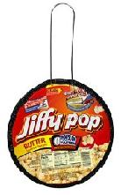                 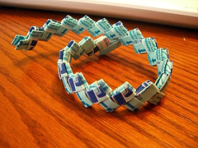  
**5 ¢ packs of baseball cards        Jiffy Pop popcorn     Gum wrapper chains**

**           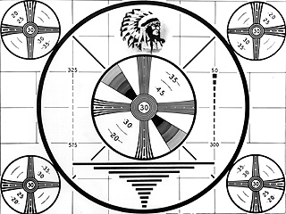**

**Flash bulbs                                        TV Test patterns**

**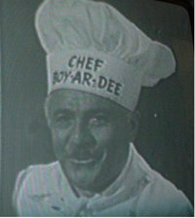      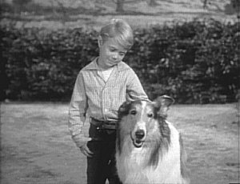        
Chef Boy-ar-dee          Timmy and Lassie                    Ding Dong Avon calling!!**

**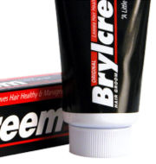      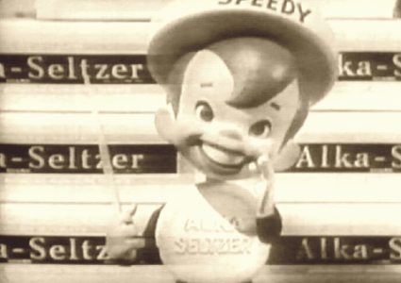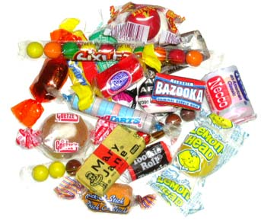  
Brylcreem                       Speedy Alka-Seltzer                                Penny candy**

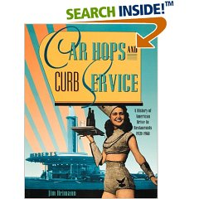                                                             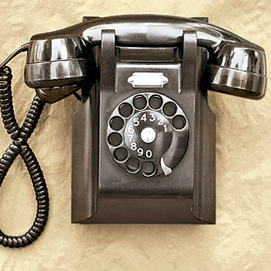      
        **Car Hops                   Telephone numbers with a word prefix...(Raymond 4-601). Party lines**

**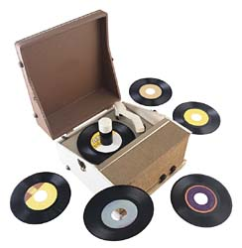                                                                    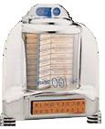  
     45 RPM records              45 rpm spindles     Table side jukeboxes**

**cid:part29.04050806.02030302@comcast.net                                                               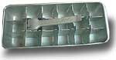         
Blackjack, Clove and Tea berry chewing gum      Metal ice cubes trays with levers**

**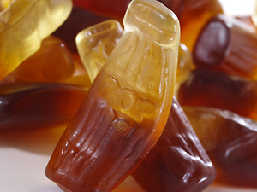                           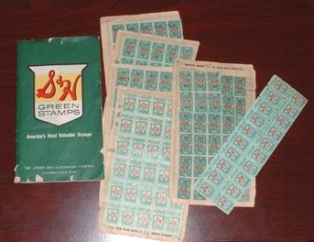**

**Wax Coke\W colored sugar water                      Green Stamps**

**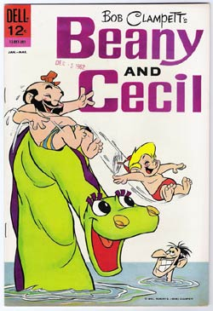     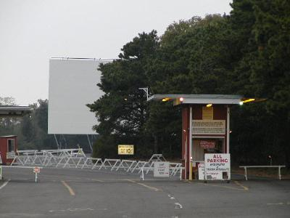      
    Beanie and Cecil                   Drive in Movies**

**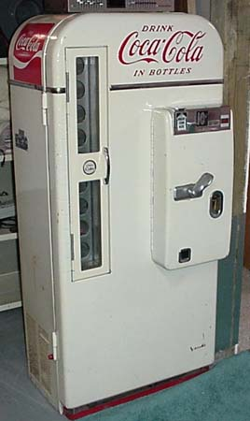          
Soda pop machines                        Sky King**  
**that dispensed glass bottles**

**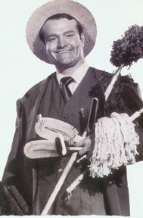     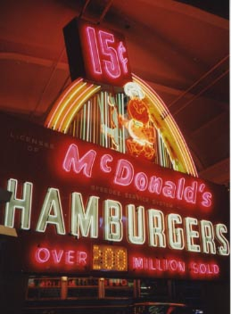          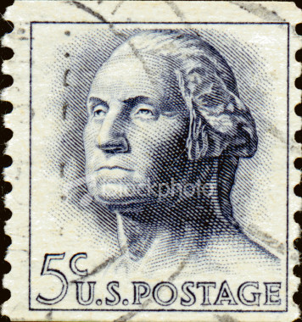  
Fuller Brush Man  15 ¢ McDonald hamburgers                   5 ¢ stamps**

**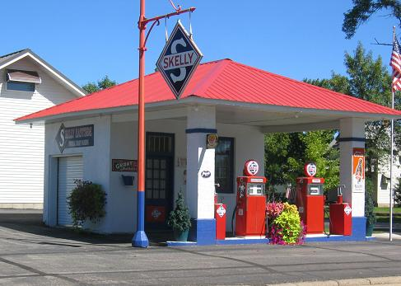         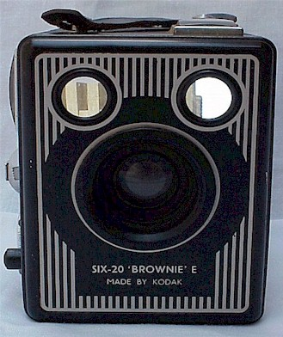  
            25 ¢ a gallon gasoline                                    Brownie camera  
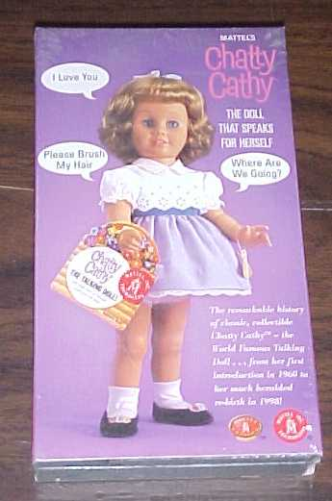     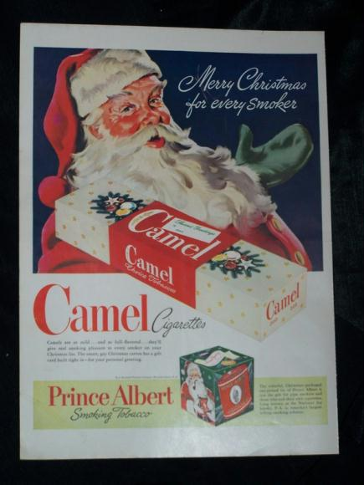  
        Chatty Cathy dolls                            Cigarettes for Christmas**

**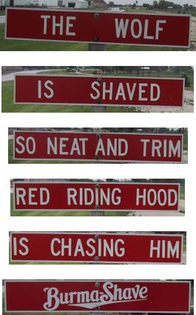                   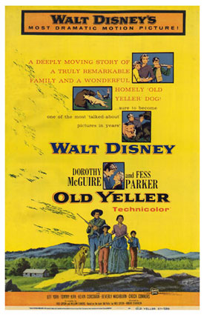**

**Burma Shave signs                                Old Yeller**

**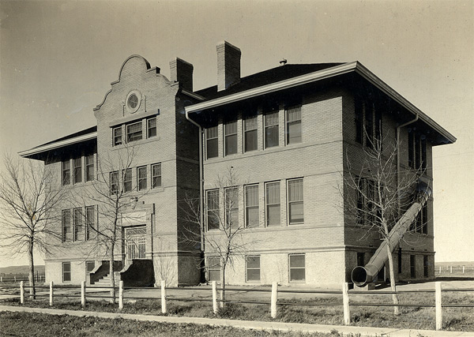  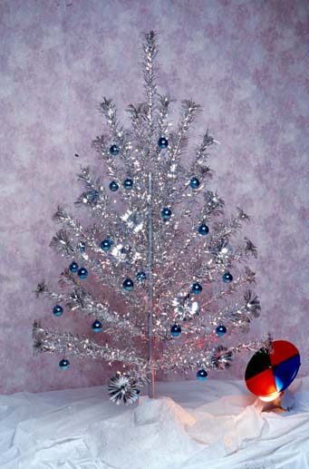  
               Fire escape tubes                                            Aluminum Christmas Trees**

**If you can remember most or all of these, then you have lived!!!!!!!**

**Pass this on to anyone who may need a break from their "grown-up" life . . .**

**I double-dog-dare-ya!**