**Amazing striped icebergs   
  
Icebergs in Lake Michigan sometimes have stripes, formed by** **layers of snow that react to different conditions.   
  
Blue stripes are often created when a crevice in the ice sheet fills up with melt water and freezes so quickly that no bubbles form.   
  
When an iceberg falls into the lake, a layer of water can freeze to the underside. If this is rich in algae, it can form a green stripe.   
  
Brown, black and yellow lines are caused by sediment, picked up when the ice sheet grinds downhill towards the lake.**   
  
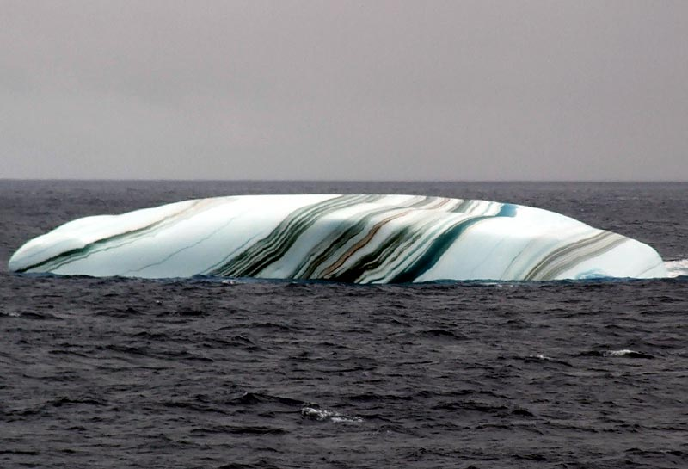  
  
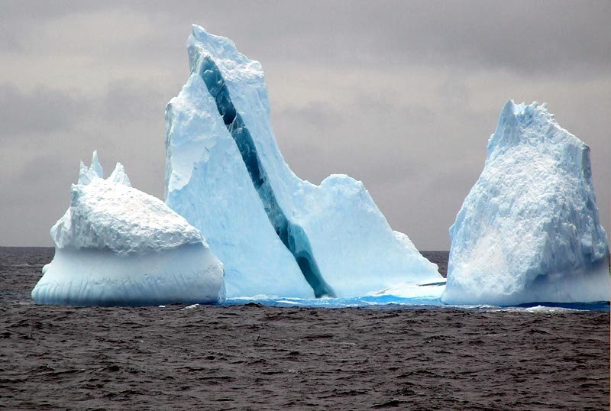  
  
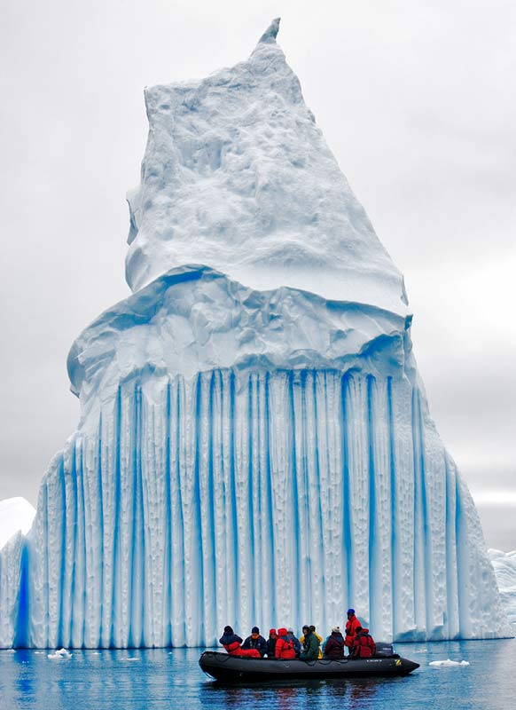  
  
**Frozen Wave Pixs - Nature is amazing!**   
  
**The water froze the instant the wave broke through the**   
**ice.  That's what it is like in  Lake Michigan where it is the**   
**coldest weather in decades.  (THANK YOU Al Gore) Water freezes the instant**   
**it comes in contact with the air.  The temperature of the**   
**water is already some degrees below freezing.**   
  
**Just look at how the wave froze in mid-air!!!**   
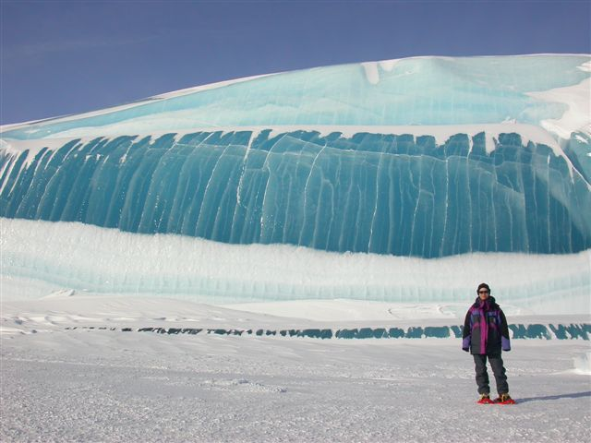  
  
  
  
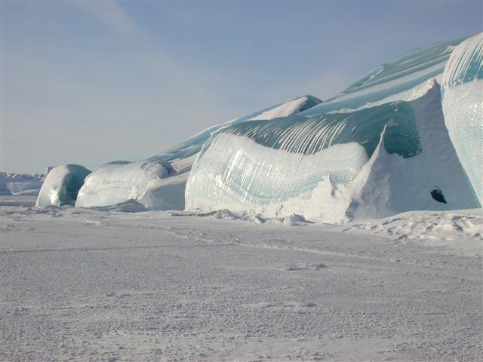  
  
  
  
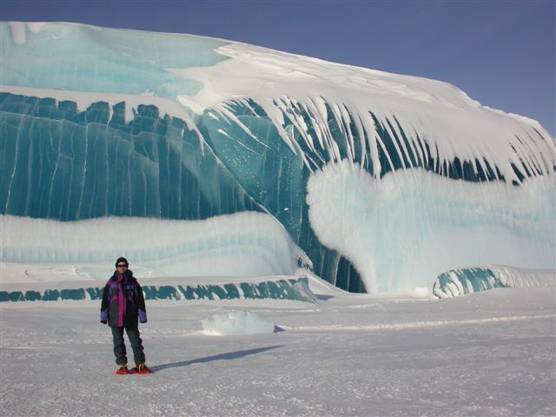  
  
  
  
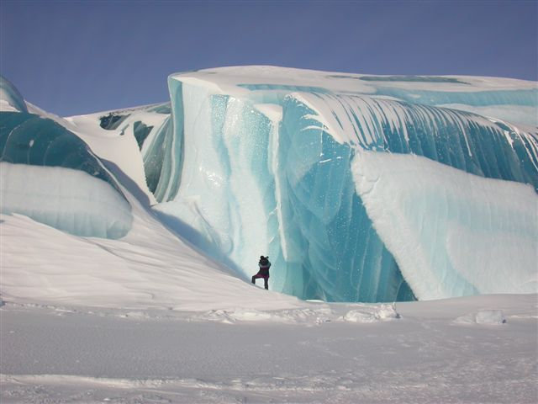  
  
  
  
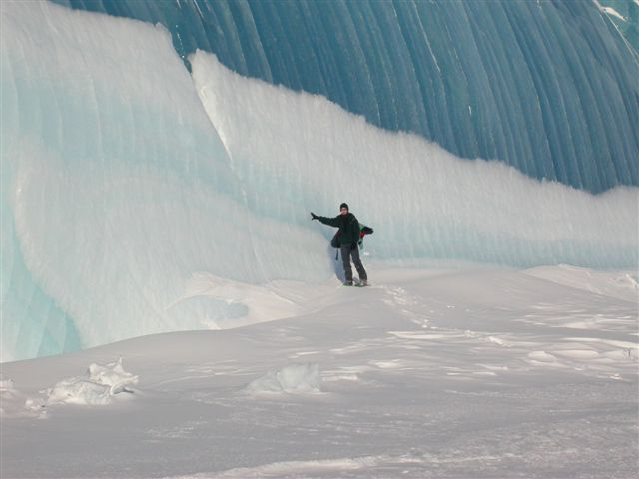  
  
  
  
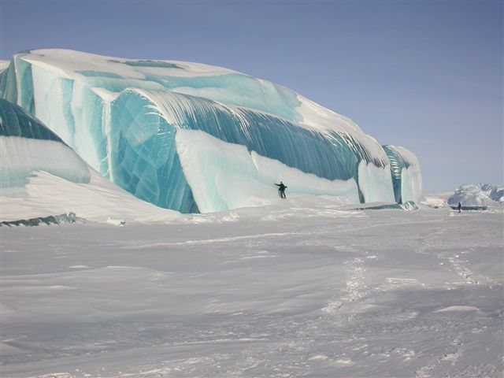  
  
  
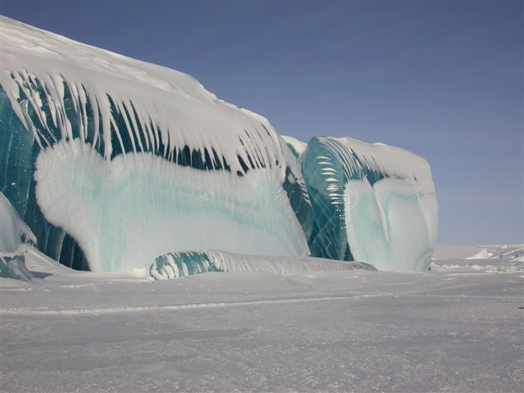  
  
  
  
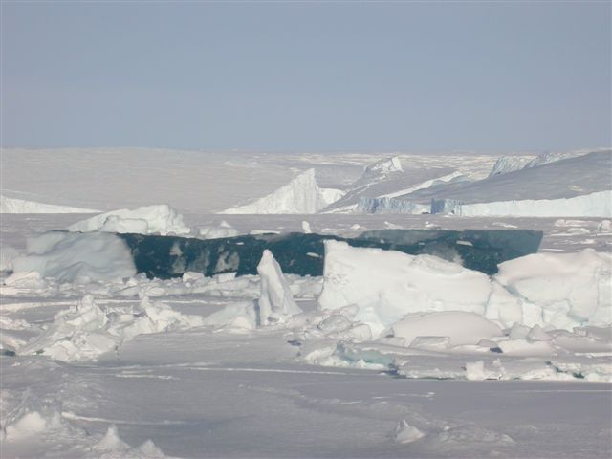  
  
  
**Having the Internet means that we get to see something**   
**that we never imagined!   Pass it on for others to enjoy!**  
  
  
