**For  those that remember back then.......**

**PRETTY COOL OLD PICTURES OF DETROIT**

***Below: Woodward Ave. between Larned & Jefferson_March 25, 1956*** ***Note Kern's in the background***   
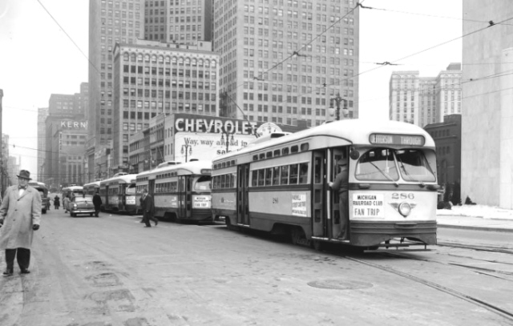  
    
***Below: Woodward at Fort St._June 19, 1952***   
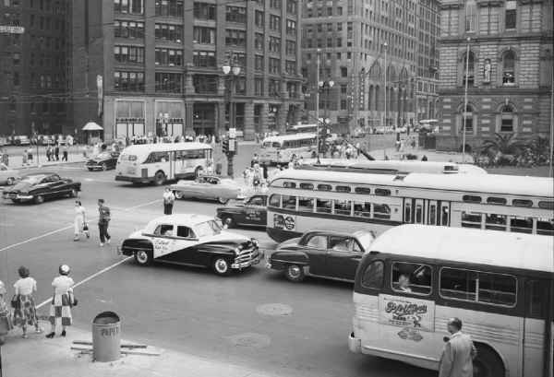  
    
    
***Below: Street car along Woodbridge at Atwater   Neat old Vernor's truck!***   
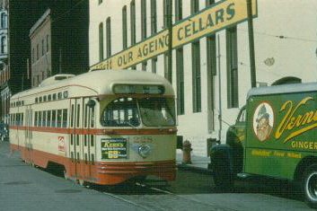  
    
***Below: John C. Lodge expressway_12-04-1950.  Note the New York Central steam locomotive crossing the Lodge!***   
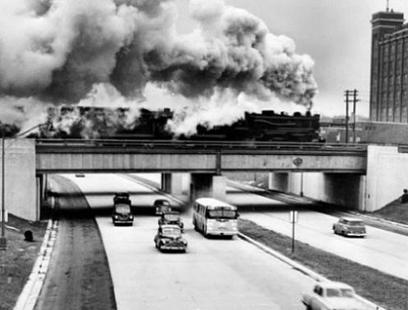  
    
***Below: Davison Ave. before_1941***     
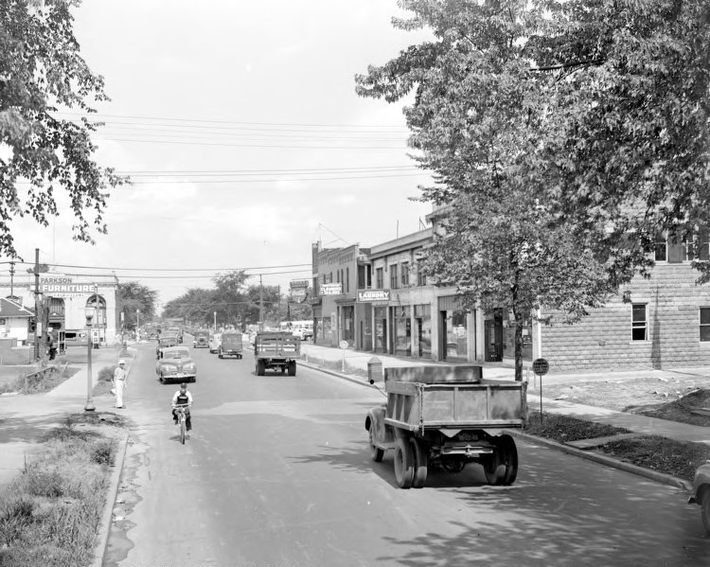  
    
***Below:  Davison Expressway after_November 1942***   
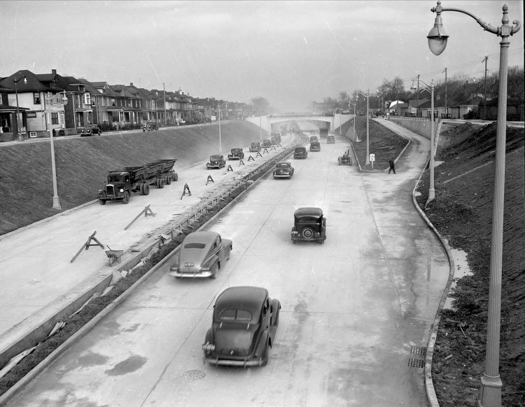  
    
    
***Below: Detroit Motor Bus route_1924.  Note the "eastside" city limit;   Helen St. was the sticks back then !!!!***   
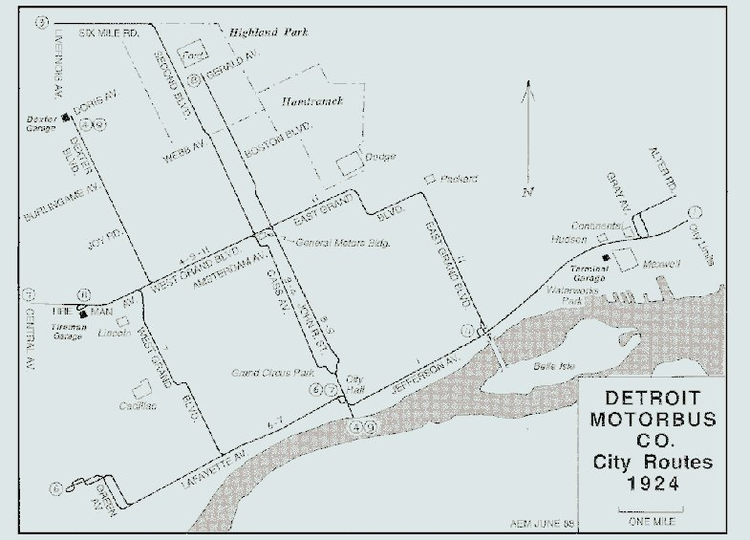  
    
***Below:  Belle Isle Motor Coach Station_1923 - Note: Electric Park in the background***   
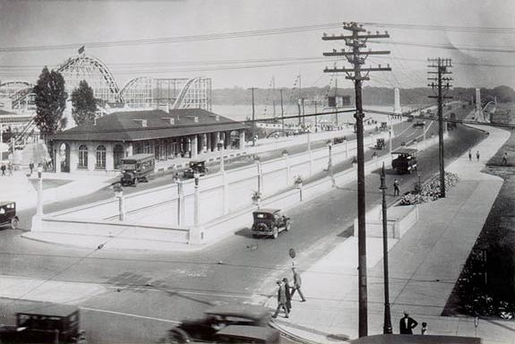  
    
    
***Below: Capitol Park Bus station_circa 1962***   
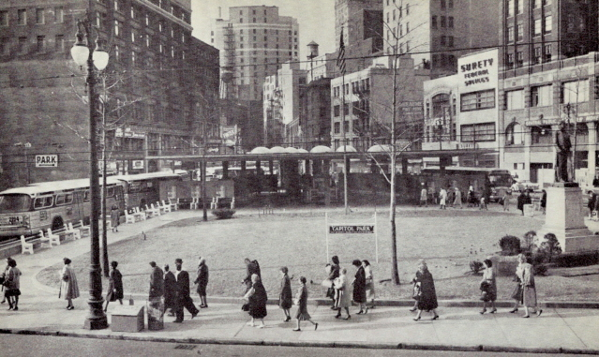  
    
    
***Below: Construction of Edsel Ford Freeway at Woodward***   
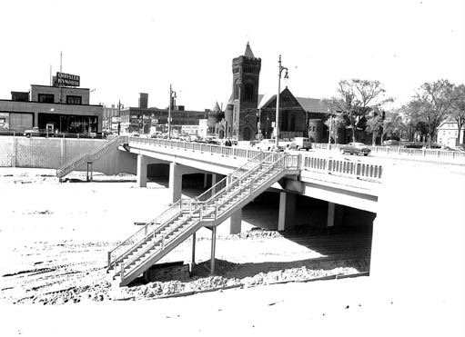  
    
***Below:  Ted, recognize the any of the names in the following photos?***   
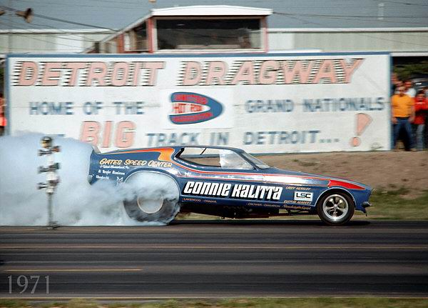    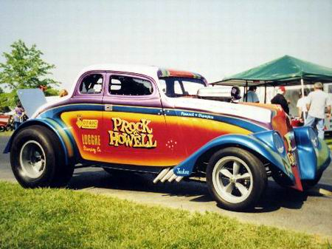  
    
    
***Below:  Memories of Sibley at Dix!!!!                                                        Below:  Cool Corvair!!!***   
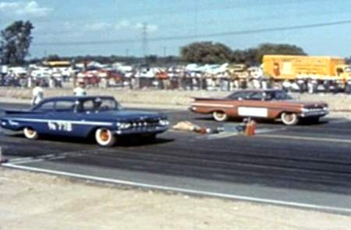    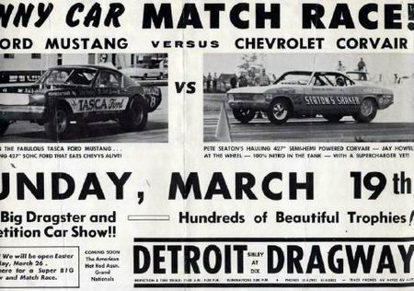  
    
    
    
    
    
    
    
**Old Detroit   
  
  
-   
  
I didn't know that Detroit had the busiest intersection in the world at one time.   
I find it hard to believe it wasn't in New York or Paris .. But, then, it is the city   
that put the world on wheels and at one time was the single manufacturing   
place for all American cars.   
  
  
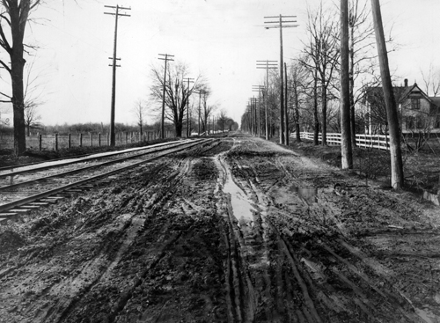  
Woodward between 6 and 7 mile roads (1908)   
  
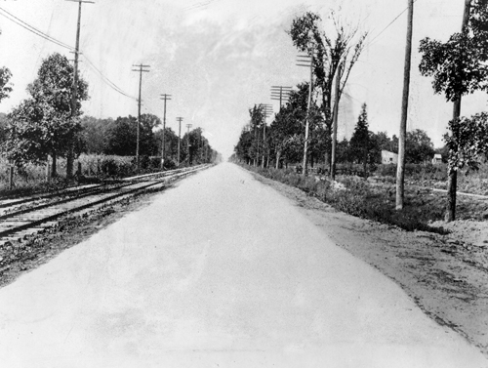  
Same stretch of road between 6 and 7 mile roads (1909)   
  
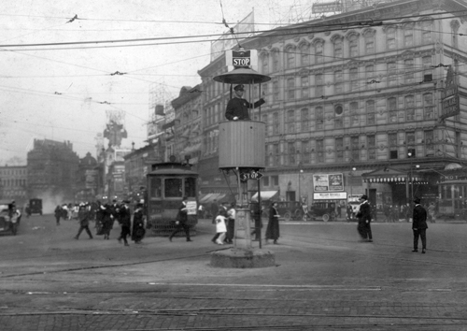  
Busiest intersection in the World; Michigan and Woodward (1920)   
  
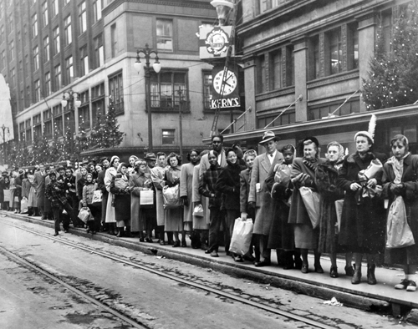  
Shoppers wait for the streetcar on Woodward at State Street , Nov. 25, 1949   
  
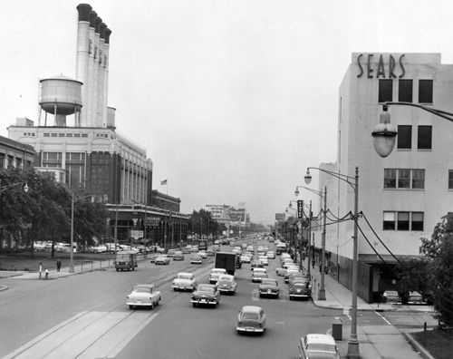  
Highland Park at Woodward and Puritan (1956)   
  
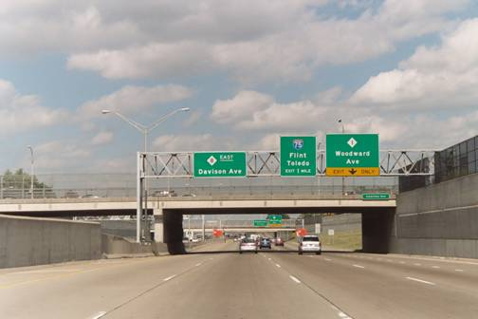  
In 1941, what had been Davison Avenue in Detroit was rebuilt into the   
world's first urban depressed freeway, opening for traffic on November 24, 1942.   
                                                                                                                                                                         
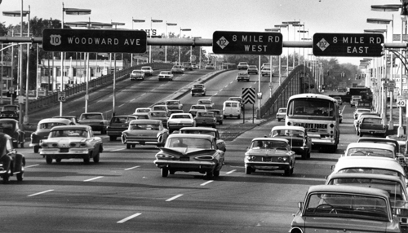  
Newly opened to help ease traffic on Woodward at 8 Mile (1965)   
  
  
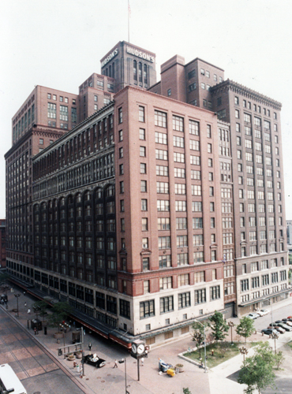  
Hudson 's building circa 1983, building was imploded in 1998.   
  
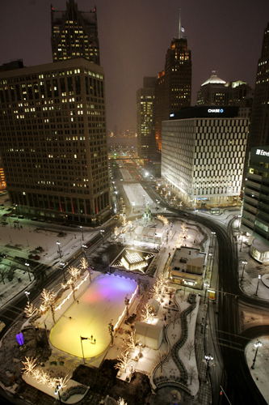  
Campus Martius has been a gathering place for Detroiters for two centuries (Jan 2007)   
  
  
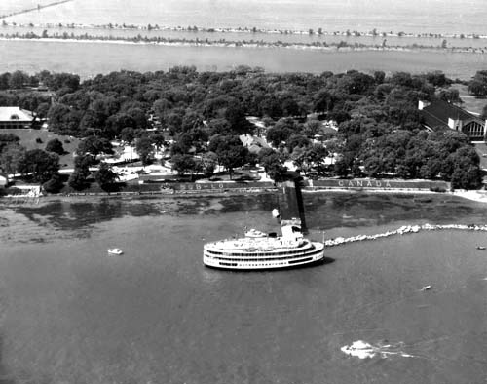  
Bob-Lo Island (1964)   
  
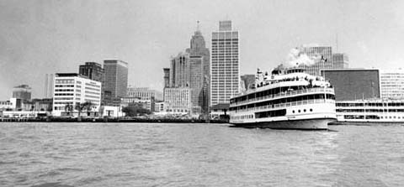  
Bob-lo Boat (1970)   
  
  
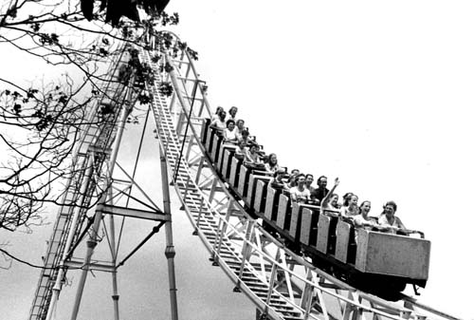  
We all rode this Roller Coaster; didn't we?????   
  
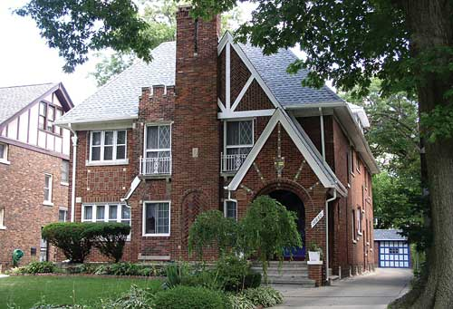   
Gladys Knights former home on LaSalle   
  
  
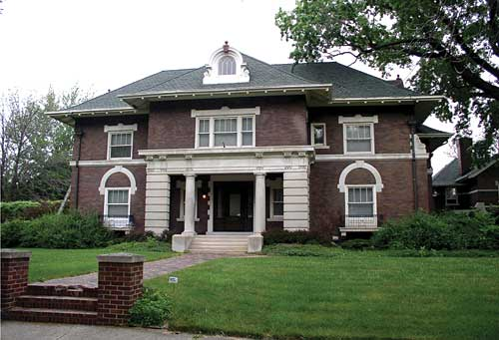  
Henry Ford's former home on Edison   
  
  
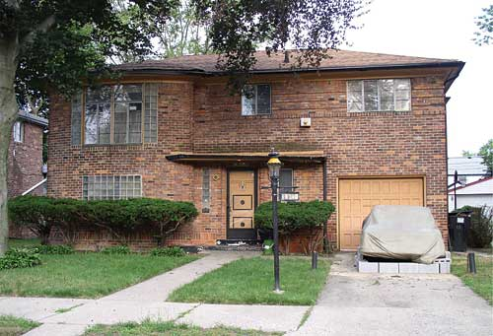  
Marvin Gaye's former home on Appoline   
  
  
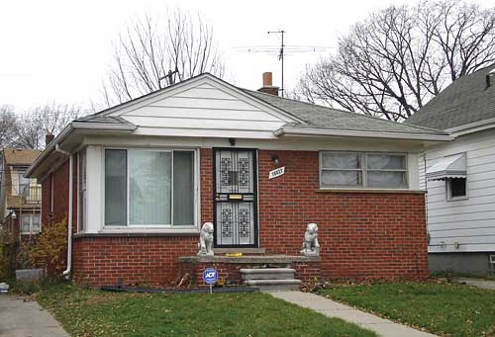  
Malcolm X's childhood home on Keystone   
  
  
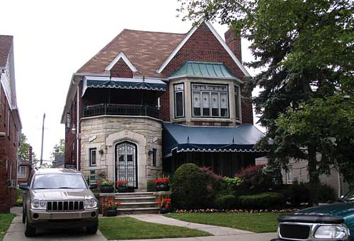  
Florence Ballard's former home on West Buena Vista   
  
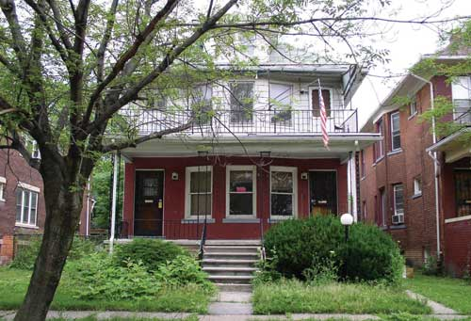  
Smokey Robinson's former home on Belmont   
  
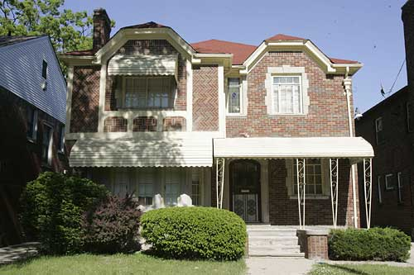  
Stevie Wonder's former home on Greenlawn   
  
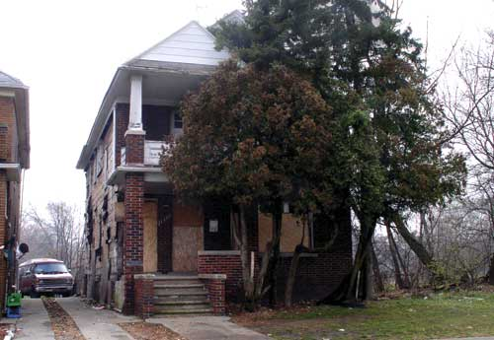   
In 1957, Mike and Marion Ilitch lived in this house on Chalfonte**