GROWING UP IN THE 1950S

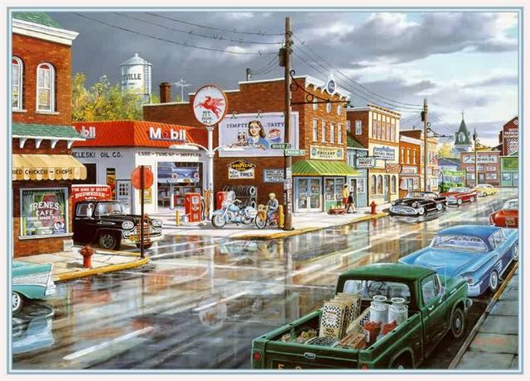 **Long ago and far away, in a land that time forgot,   
Before the days of Dylan , or the dawn of Camelot.   
There lived a race of innocents, and they were you and me,**   
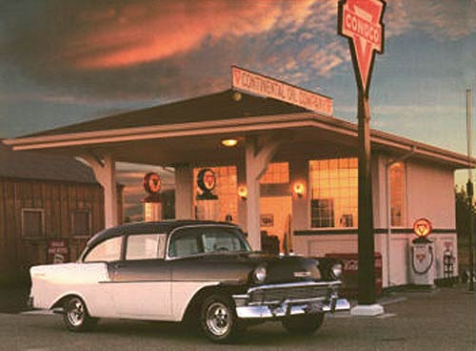 **For Ike was in the White House in that land where we were born,   
Where navels were for oranges, and  Peyton Place was porn.**   
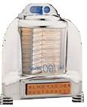 **We learned to gut a muffler, we washed our hair at dawn,   
We spread our crinolines to dry in circles on the lawn..**   
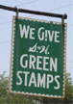 **We longed for love and romance, and waited for our Prince,   
And Eddie Fisher married Liz , and no one 's seen him since.**   
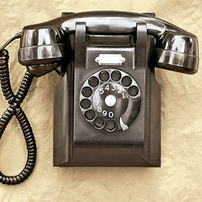 **We danced to 'Little Darlin,' and sang to 'Stagger Lee'  
And cried for Buddy Holly in the Land That Made Me, Me.**   
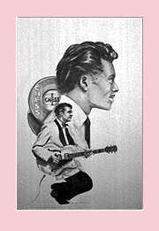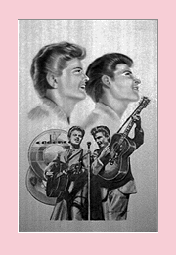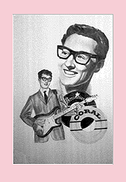 **Only girls wore earrings then, and 3 was one too many,   
And only boys wore flat-top cuts, except for Jean McKinney.**   
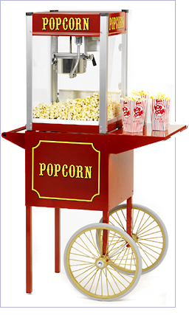 **And only in our wildest dreams did we expect to see   
A boy named George with Lipstick, in the Land That Made Me, Me.**   
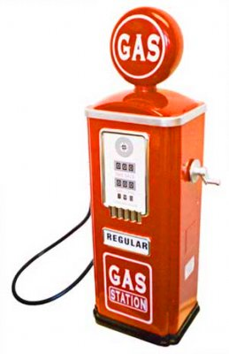 **We fell for Frankie Avalon , Annette was oh, so nice,   
And when they made a movie, they never made it twice..**   
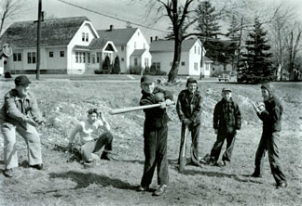 **We didn't have a Star Trek Five, or Psycho Two and Three,   
Or Rocky-Rambo Twenty in the Land That Made Me, Me.**   
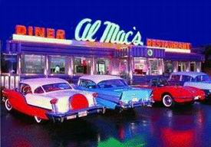 **Miss Kitty had a heart of gold, and Chester had a limp,   
And Reagan was a Democrat whose co-star was a chimp.**   
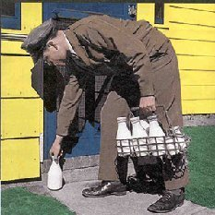 **We had a Mr. Wizard, but not a Mr. T,   
And Oprah couldn't talk yet, in the Land That Made Me, Me.   
We had our share of heroes, we never t hought they'd go,   
At least not Bobby Darin, or Marilyn Monroe.**   
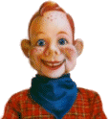 **For youth was still eternal, and life was yet to be,   
And Elvis  ;was forever in the Land That Made Me, Me.**   
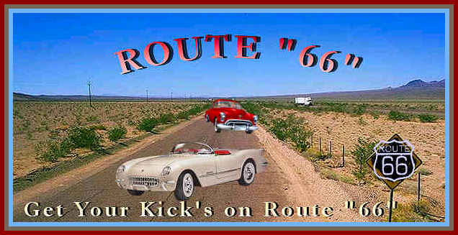 **We'd never seen the rock band that was Grateful to be Dead,   
And Airplanes weren't named Jefferson , and Zeppelins were not Led.**   
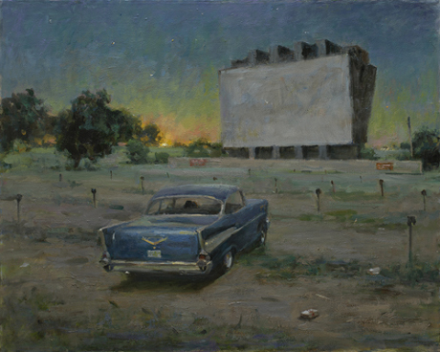 **And Beatles lived in gardens then, and Monkees lived in trees,   
Madonna was Mary in the Land That Mad e Me, Me.**   
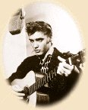 **We'd never heard of microwaves, or telephones in cars,   
And babies might be bottle-fed, but they were not grown in jars.**   
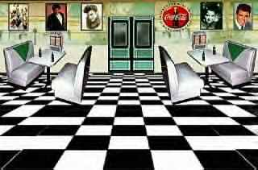 **And pumping iron got wrinkles out, and 'gay' meant fancy-free,   
And dorms were never co-ed in the Land That Made Me, Me.**   
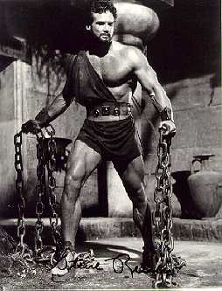 **We hadn't seen enough of jets to talk about the lag,   
And microchips were what was left at the bottom of the bag.**   
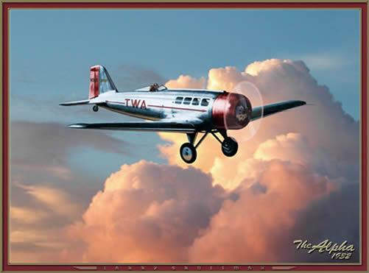 **And hardware was a box of nails, and bytes came from a flea,   
And rocket ships were fiction in the Land That Made Me, Me.**   
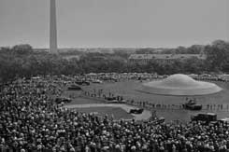 **Buicks came with portholes, and side shows came with freaks,   
And bathing suits came big enough to cover both your cheeks.**   
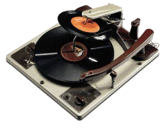 **And Coke came just in bottles, and skirts below the knee,   
And Castro came to power near the Land That Made Me, Me.**   
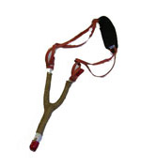 **We had no Crest with Fluoride, we had no Hill Street Blues,   
We had no patterned pantyhose or Lipton herbal tea   
Or prime-time ads for those dysfunctions in the Land That Made Me,** **Me.**   
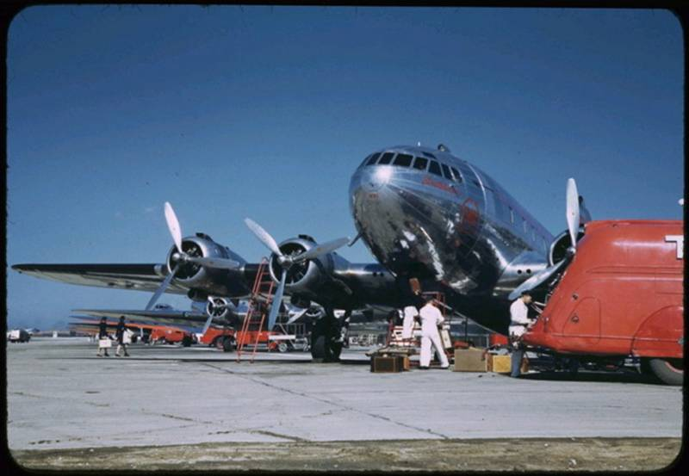 **There were no golden arches, no Perrier to chill,   
And fish were not called Wanda , and cats were not called Bill.**   
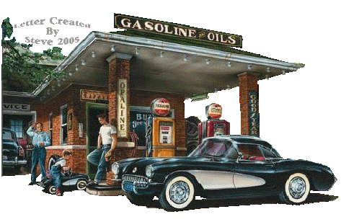 **And middle-aged was 35 and old was forty-three,   
And ancient were our parents in the Land That Made Me, Me. </ B>  
  
But all things have a season, or so we've heard them say,   
And now instead of Maybelline we swear by Retin-A.   
They send us invitations to join AARP,   
We've come a long way, baby, from the Land That Made Me, Me.   
  
So now we face a brave new world in slightly larger jeans,   
And wonder why they're using smaller print in magazines.   
And we tell our children's children of the way it used to be,   
Long ago and far away in the Land That Made Me, Me.   
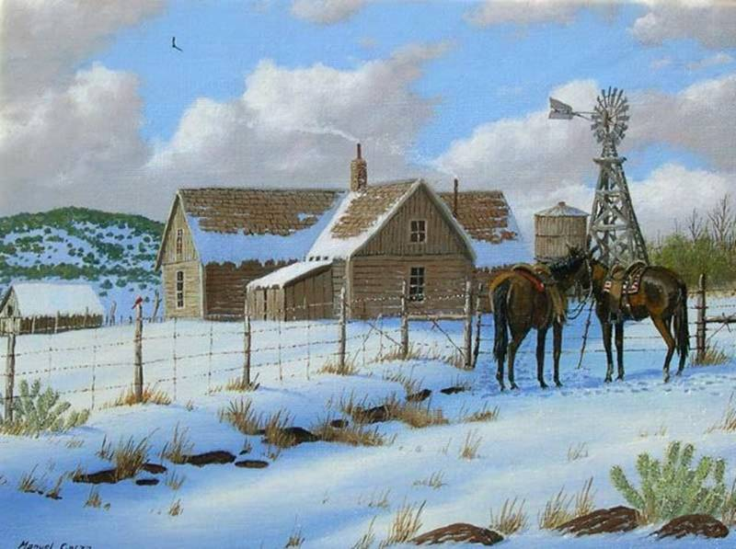  
If you didn't grow up in the fiftys,   
you missed the greatest time in history.**